JŌNOUCHI, Motoharu (1935--December 10, 1986)

Jōnouchi Motoharu was a Japanese experimental filmmaker whose films recorded glimpses of the student movement and countercultural environment of Tokyo in the 1960s and early 1970s. He made films with the Nihon University Film Club as an art student in the late 1950s before co-founding the VAN Film Research Centre, a collective of filmmakers who lived and worked in a shared house in Tokyo. VAN became a gathering place for many experimental artists, and Jōnouchi’s films reflect the interdisciplinarity of the space: he collaborated with the performance and music collectives Hi Red Centre and Group Ongaku, among others. His “Gewaltopia” series documented political struggles leading up to the 1970 US-Japan Security Treaty renewal. *Gebarutopia yokokuhen* (*Gewaltopia Trailer*, 1968) layered images of mushroom clouds and silent-era movie monsters with footage of skirmishes between student activists and police. In *Shinjuku Sutēshon* (*Shinjuku Station*, 1974) he read a poem in front of a movie screen awash in images of a 1968 anti-war demonstration. In these and other films, he used frame-by-frame exposures and in-camera edits to construct kaleidoscopic patterns. He approached projection as a unique event, often re-editing his films and presenting them in the context of performances and happenings. His work was influenced by the Neo-Dadaists and reflects developments in expanded cinema and anti-art collectivism that took place in 1960s Japan. He later worked in television documentary. A last film about the northern prefecture of Hokkaidō and the Ainu people remained incomplete at the time of his death.

**Selected works:**

*PuPu* (1959, with the Nihon University Film Club)

*Shelter Plan* (*Sherutā puran*,1964)

*Gewaltopia Trailer* (*Gebarutopia Yokokuhen*, 1968)

*WOLS* (completed1969)

*Shinjuku Station*(*Shinjuku Sutēshon*,1974)

**Further reading:**

Jōnouchi, M. (ed.) (2011) *Jōchan ariki: Jōnouchi Motoharu kaisōbun-shū*. Tokyo: Shichigatsudō.

Sas, M. (2011) *Experimental Arts in Postwar Japan*. Cambridge: Harvard University East Asia Monographs.

Paratextual material:

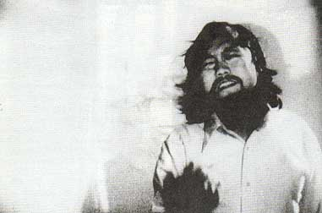

Still from *Shinjuku Station*

Ryan Cook

Harvard University